**1. How can we connect multiple independent sheets into one sheet while developing dashboard.**

**Ans:**

* We can connect to two different sheets in the following. Connecting to multiple sheets is nothing but in single dashboard adding data sources simultaneously.
* Add a new data source by selecting new data source in Data menu.
* Choose the same spreadsheet and choose a different sheet inside it and just drag out the sheet.
* While the sheet is still empty, make sure you have your second data source selected. When you click the data source right under the tab that says Data, the dimensions and measures will switch to the data source for whatever you select.
* You can now drag and drop them out to the sheet to create a visualizations  
  Create a new dashboard. There's a dropdown on the toolbar button or you can find it in the Dashboard menu.  
   Drag sheets onto the dashboard-- they can be from any of the data sources.

**2. Which library helps to connect R with Tableau?**

Ans: Rserve is the tool used to connect to Tableau.

1. Steps to connect to tableau
2. library(Rserve)
3. Execute the file Rserve.exe
4. Now we will connect Tableau to R server using following
5. **Help –> Setting and Performance –> Manage external Service connection**
6. Auto populated values for Server as “Localhost” and port as “6311”.
7. Click on Test connection to check the connection, it will show successfully connected to Rserve in pop-up
8. This will help Tableau to execute script commands like:  
   Script_BOOL  
   Script_INT  
   Script_STR  
   Script_REAL
9. Example to calculate outliers
10. Now, we will create an calculated field “Outliers” using following code to find outliers in the FMCG data:
11. IF SCRIPT_REAL(“library(pracma); a <- rep(1, length(.arg1)); a[findpeaks(.arg1,threshold=quantile(.arg1,.99),sortstr=FALSE)[,2]]=0;a;”, SUM([Sales])) == 0  
    THEN “Outlier”  
    ELSE “OK”  
    END

**3. What are the different data sources we can connect with tableau?**

**Ans:** The following are the data sources that we can connect using Tableau.

* **Files** such as CSV, Excel, json, text etc.
* Oracle, Sql Server, DB2, Nosql etc.
* **Cloud Systems**  Windows Azure, Google BigQuery, etc.

**4. How can we share tableau dashboard with others?**

**Ans:** There are various ways to publish Tableau results online. The following are few prescribed in Tableau documentation.

## *Tableau Public*

1. Select Server > Tableau Public > Save to Tableau Public.
2. Enter your Tableau Public credentials in the dialog box.
3. select Server > Tableau Public > Save to Tableau Public.

* Embed on your website: Copy the Embed Code and paste it in your web page HTML.
* Send a link: Copy the Link and send to your colleagues.
* Send an email using your default email client: Click the email icon.
* Share on Twitter or Facebook

## *Tableau Server*

* Select Server > Publish Workbook or click Share https://help.tableau.com/current/guides/get-started-tutorial/en-us/Img/Share_Icon.png on the toolbar.
* Enter the name of the server (or IP address) you want to connect to in the dialog box and click Connect.
* Provide the Label
* Click on Publish
* Send a link: Copy the Link and send to your colleagues.
* Send an email using your default email client: Click the email icon.

**5. Develop bar graph and histogram in tableau using any data. Share visualizations with us.**

**Ans:**

**Histogram**

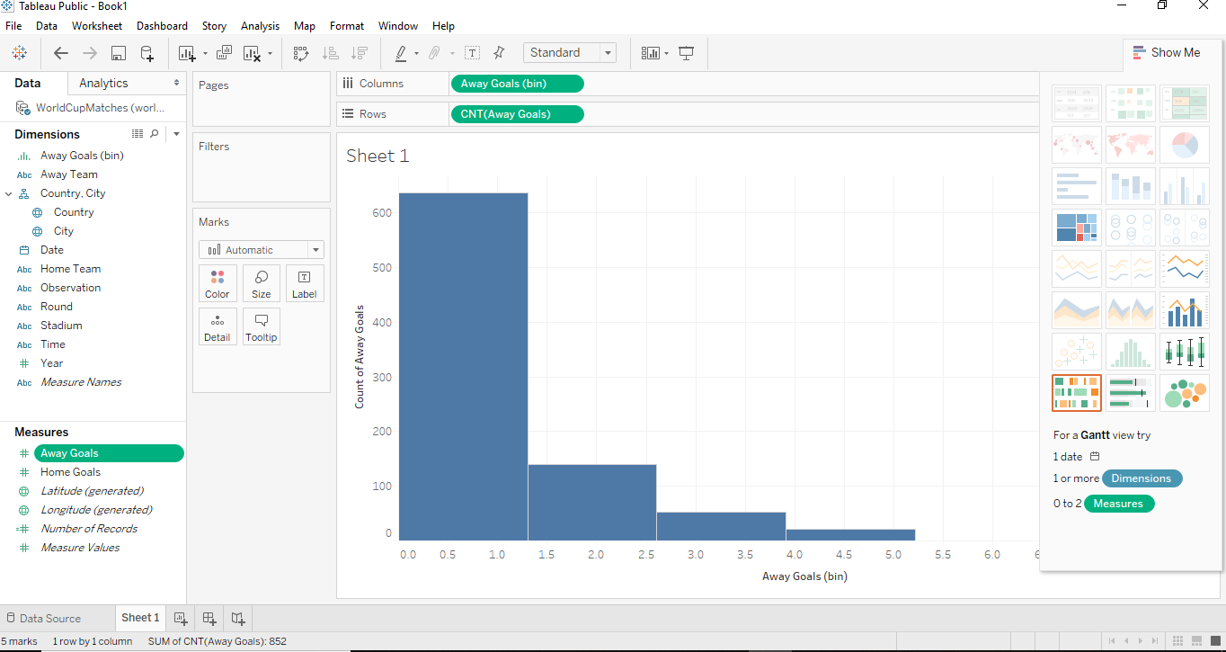

**BAR GRAPH**

